**Description of data sources**

**BIXI data**

Although the BIXI network has been operating in Montreal since 2009, the original operating company filed for bankruptcy in 2014. The city of Montreal bought the company’s assets and used the existing infrastructure to establish BIXI Montreal in 2014. As a result, ridership data is available online only from 2014 onwards.

These publically available datasets provide details of each BIXI trip, including start date/time, end date/time, start station code, end station code, trip duration in seconds, and a logical variable *is_member*, indicating whether the rider was a long-term subscriber or an occasional rider.

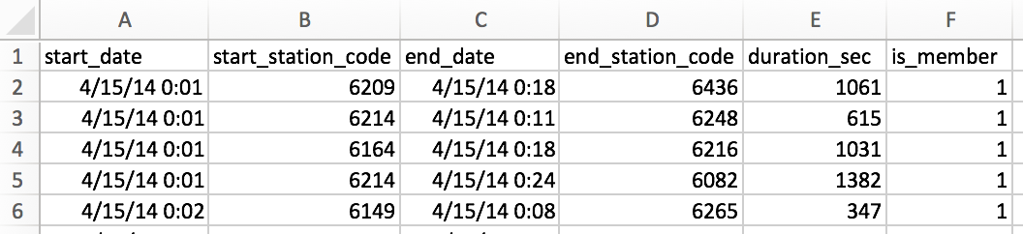

They also provide a station list for each year, which includes a unique station code, name, and latitude and longitude coordinates for each BIXI station.

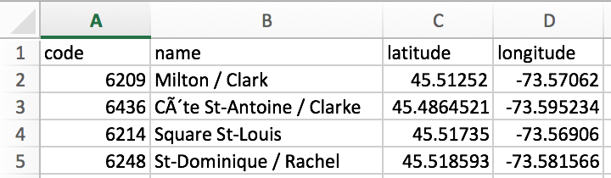

**Environment Canada data**

In addition to the BIXI data, this project will use archived meteorological data from the Environment Canada meteorological station at Pierre Elliott Trudeau Airport in Montreal. This data exists as both hourly and daily datasets.

Included in the hourly datasets are hourly temperature, relative humidity and wind speed measurements:

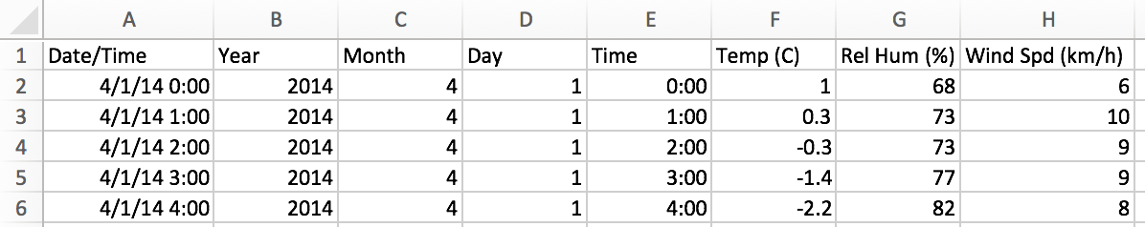

The daily datasets include daily min, max and mean temperatures, the total precipitation amount in millimeters, and the speed of the max wind gust:

